USB Evolution -

USB introduced to standardize the connector.

Before USB, each manufacturer was making their own connector.

USB – Unified Bus for slow devices.

Design based on Master-Slave concept.

USB Host Controller is a single master.

USB Host controller polls the slave peripherals/devices.
Never an interrupt from usb device to host controller. Just polling.

USB host controller, in turn being a PCI device (on PCs) can interrupt the CPU.

Later high speed USB 2.0 and USB 3.0 added.

USB Host and USB Gadget.

USB Host runs on host and is the master. It drives the slave devices.

USB Gadget runs on the device and responds to a host.

USB Host Subsystem

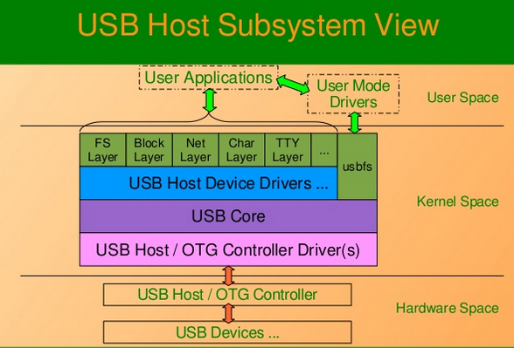

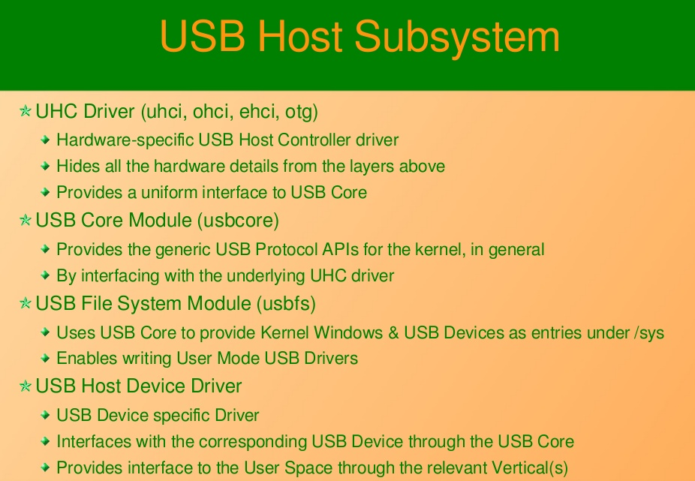

USB Gadget Subsytem View

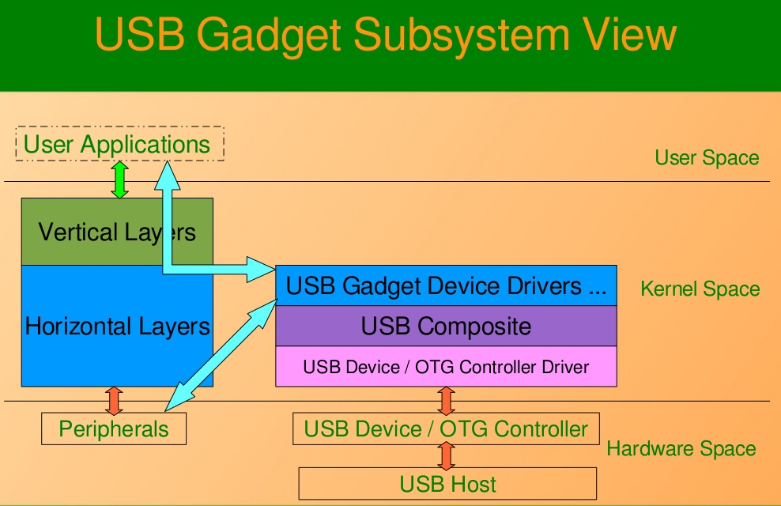

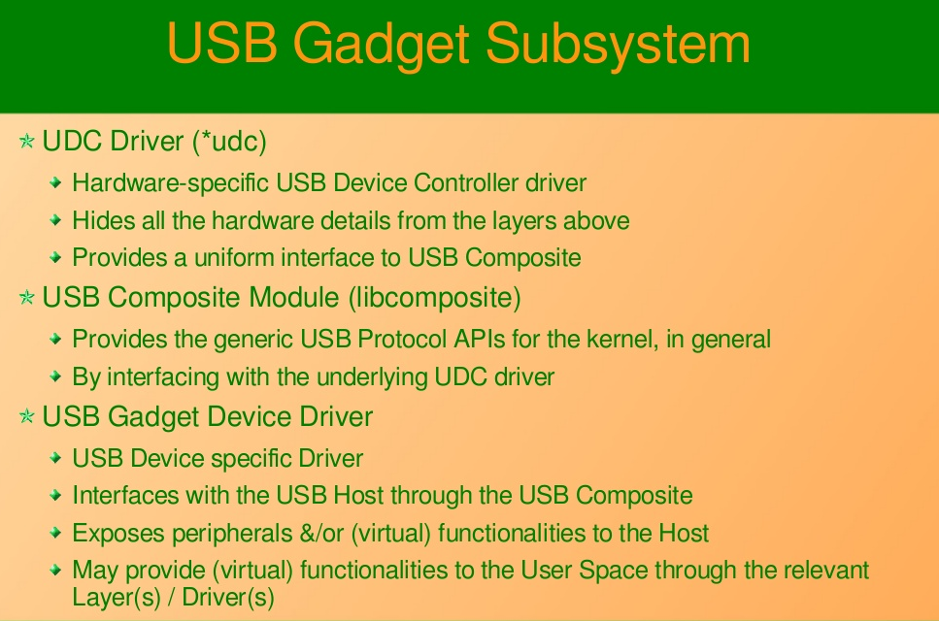

/sys/kernel/debug/usb/devices – shows all the details of the usb devices/hubs.

USB Protocol

Device ----> Config(s) ----> Interfaces -----> Endpoints

Driver/Interface.

Endpoints

Direction ---> Input (MSB 1 in address) and Output(MSB 0 in address)

OUT (Host ---> Device always)

IN (Device ---> Host always)

Types
- Control (always present – bidirectional. Only bidirectional endpoint)

- Interrupt (small & fast, eg: serial drivers)

- Bulk (larger volume, eg: hard disk)

- Isochronous (no data integrity, fast, eg: webcam)

USB Host Device Driver – APIs and structures

<linux/usb.h>

struct usb_device

struct usb_host_config

struct usb_interface
-interface_to_usb

struct usb_endpoint
struct usb_endpoint_descriptor

USB core functionality

- USB Host Device Driver Registration

- USB Host Device Hot plugability
probe: vertical registration
disconnect: vertical unregistration
- USB transfers through URBs

USB Host Device Driver Registration

struct usb_driver
.owner=
.name=
.id_table=
.probe=
.disconnect=

int usb_register(struct usb_driver *);
int usb_deregister(struct usb_driver*);

USB Host Device Hot plugability

callback probe
int usb_register_dev(intf,class);

callback disconnect
int usb_deregister_dev(intf,class);

other useful APIs
void usb_set_intfdata(intf, void *data);
void* usb_get_intfdata(intf);

USB transfers through URBs
USB Wiki

Universal Serial Bus (USB) is an industry standard that establishes specifications for cables and connectors and protocols for connection, communication and power supply between computers, peripheral devices and other computers.

USB was designed to standardize the connection of peripherals to personal computers, both to communicate with and to supply electric power. It has largely replaced interfaces such as serial ports and parallel ports, and has become commonplace on a wide range of devices.

The Universal Serial Bus was developed to simplify and improve the interface between personal computers and peripheral devices, when compared with previously existing standard or ad-hoc proprietary interfaces.

The USB interface is self-configuring, so the user need not adjust settings on the device and interface for speed or data format, or configure interrupts, input/output addresses, or direct memory access channels.

USB devices often do not have user-adjustable interface settings. The USB interface is "hot pluggable", meaning devices can be exchanged without rebooting the host computer. Small devices can be powered directly from the USB interface, displacing extra power supply cables.

the USB interface defines protocols for recovery from common errors, improving reliability over previous interfaces.

Limitations:
-USB cables are limited in length,
-USB has a strict "tree" topology and "master-slave" protocol for addressing peripheral devices; peripheral devices cannot interact with one another except via the host, and two hosts cannot communicate over their USB ports directly. Some extension to this limitation is possible through USB On-The-Go.
-A host cannot "broadcast" signals to all peripherals at once—each must be addressed individually. -Some very high speed peripheral devices require sustained speeds not available in the USB standard.
-Developers of USB devices intended for public sale generally must obtain a USB ID which requires a fee paid to the Implementers' Forum.

Speeds

USB 1.0
Low speed - 1.5 Mb/s
Full speed – 12 Mb/s

USB 2.0
Low speed – 1.5 Mb/s
Full speed – 12 Mb/s
High speed – 480 Mb/s

USB 3.0
Superspeed – 5 Gb/s
USB 3.1
Superspeed+ - 10 Gb/s

USB 3.2
Superspeed+ - 20 Gb/s

USB 4
Superspeed+ and Thunderbolt – 40 Gb/s

System Design

A USB system consists of a host with one or more downstream ports, and multiple peripherals, forming a tiered-star topology. Additional USB hubs may be included, allowing up to five tiers. A USB host may have multiple controllers, each with one or more ports. Up to 127 devices may be connected to a single host controller.

USB devices are linked in series through hubs. The hub built into the host controller is called the root hub.

A USB device may consist of several logical sub-devices that are referred to as device functions. A composite device may provide several functions, for example, a webcam (video device function) with a built-in microphone (audio device function).

An alternative to this is a compound device, in which the host assigns each logical device a distinct address and all logical devices connect to a built-in hub that connects to the physical USB cable.

USB device communication is based on pipes (logical channels). A pipe is a connection from the host controller to a logical entity within a device, called an endpoint. Because pipes correspond to endpoints, the terms are sometimes used interchangeably. Each USB device can have up to 32 endpoints (16 in and 16 out),

Endpoints are defined and numbered by the device during initialization (the period after physical connection called "enumeration") and so are relatively permanent, whereas pipes may be opened and closed.

There are two types of pipe: stream and message.
- A message pipe is bi-directional and is used for control transfers. Message pipes are typically used for short, simple commands to the device, and for status responses from the device, used, for example, by the bus control pipe number 0.
- A stream pipe is a uni-directional pipe connected to a uni-directional endpoint that transfers data using an isochronous,[44] interrupt, or bulk transfer:
Isochronous transfers
At some guaranteed data rate (for fixed-bandwidth streaming data) but with possible data loss (e.g., realtime audio or video)

Interrupt transfers
Devices that need guaranteed quick responses (bounded latency) such as pointing devices, mice, and keyboards

Bulk transfers
Large sporadic transfers using all remaining available bandwidth, but with no guarantees on bandwidth or latency (e.g., file transfers)

How data transfer starts in USB?
When a host starts a data transfer, it sends a TOKEN packet containing an endpoint specified with a tuple of (device_address, endpoint_number). If the transfer is from the host to the endpoint, the host sends an OUT packet (a specialization of a TOKEN packet) with the desired device address and endpoint number.
If the data transfer is from the device to the host, the host sends an IN packet instead. If the destination endpoint is a uni-directional endpoint whose manufacturer's designated direction does not match the TOKEN packet (e.g. the manufacturer's designated direction is IN while the TOKEN packet is an OUT packet), the TOKEN packet is ignored. Otherwise, it is accepted and the data transaction can start. A bi-directional endpoint, on the other hand, accepts both IN and OUT packets.
Endpoints are grouped into interfaces and each interface is associated with a single device function. An exception to this is endpoint zero, which is used for device configuration and is not associated with any interface. A single device function composed of independently controlled interfaces is called a composite device. A composite device only has a single device address because the host only assigns a device address to a function.
When a USB device is first connected to a USB host, the USB device enumeration process is started. The enumeration starts by sending a reset signal to the USB device. The data rate of the USB device is determined during the reset signaling. After reset, the USB device's information is read by the host and the device is assigned a unique 7-bit address. If the device is supported by the host, the device drivers needed for communicating with the device are loaded and the device is set to a configured state. If the USB host is restarted, the enumeration process is repeated for all connected devices.

USB Device Classes
The functionality of a USB device is defined by a class code sent to a USB host. This allows the host to load software modules for the device and to support new devices from different manufacturers.

Power:
USB supplies power at 5V±5% to power USB downstream devices.

USB Host Driver
<linux/usb.h>

struct usb_device usbdev;
struct usb_host_config usbconfig;
struct usb_interface interface1;
struct usb_host_endpoint endpoint1;
struct usb_endpoint_descriptor endpoint1_desc;

USB Core Functionality

-host device driver registration
-usb host device hot plugability
probe: vertical registration
disconnect: vertical unregistration
-USB transfers through URBs.

struct usb_device usbdev{
.owner=THIS_MODULE,
.name=”mysub”,
.id_table=thistable,
.probe=usbprobefn,
.disconnect=usbdisconnectfn,
};

Topologically, a USB subsystem is not laid out as a bus; it is rather a tree built out of several point-to-point links.

The USB host controller is in charge of asking every USB device if it has any data to send. Because of this topology, a USB device can never start sending data without first being asked to by the host controller.

a single-master implementation in which the host computer polls the various peripheral devices.

The Linux kernel supports two main types of USB drivers: drivers on a host system and drivers on a device. The USB drivers for a host system control the USB devices that are plugged into it, from the host's point of view

The USB drivers in a device, control how that single device looks to the host computer as a USB device. As the term "USB device drivers" is very confusing, the USB developers have created the term "USB gadget drivers" to describe the drivers that control a USB device that connects to a computer

The most basic form of USB communication is through something called an endpoint. A USB endpoint can carry data in only one direction, either from the host computer to the device (called an OUT endpoint) or from the device to the host computer (called an IN endpoint). Endpoints can be thought of as unidirectional pipes.

Control endpoints are used to allow access to different parts of the USB device. They are commonly used for configuring the device, retrieving information about the device, sending commands to the device, or retrieving status reports about the device. These endpoints are usually small in size. Every USB device has a control endpoint called "endpoint 0" that is used by the USB core to configure the device at insertion time. These transfers are guaranteed by the USB protocol to always have enough reserved bandwidth to make it through to the device.

Interrupt endpoints transfer small amounts of data at a fixed rate every time the USB host asks the device for data. These endpoints are the primary transport method for USB keyboards and mice. They are also commonly used to send data to USB devices to control the device, but are not generally used to transfer large amounts of data

Bulk endpoints transfer large amounts of data. These endpoints are usually much larger (they can hold more characters at once) than interrupt endpoints. They are common for devices that need to transfer any data that must get through with no data loss. These transfers are not guaranteed by the USB protocol to always make it through in a specific amount of time. If there is not enough room on the bus to send the whole BULK packet, it is split up across multiple transfers to or from the device. These endpoints are common on printers, storage, and network devices.

Isochronous endpoints also transfer large amounts of data, but the data is not always guaranteed to make it through. These endpoints are used in devices that can handle loss of data, and rely more on keeping a constant stream of data flowing. Real-time data collections, such as audio and video devices, almost always use these endpoints.

Control and bulk endpoints are used for asynchronous data transfers, whenever the driver decides to use them. Interrupt and isochronous endpoints are periodic. This means that these endpoints are set up to transfer data at fixed times continuously, which causes their bandwidth to be reserved by the USB core.
USB endpoints are described in the kernel with the structure struct usb_host_endpoint. This structure contains the real endpoint information in another structure called struct usb_endpoint_descriptor. The latter structure contains all of the USB-specific data in the exact format that the device itself specified. The fields of this structure that drivers care about are:

bEndpointAddress
This is the USB address of this specific endpoint. Also included in this 8-bit value is the direction of the endpoint. The bitmasks USB_DIR_OUT and USB_DIR_IN can be placed against this field to determine if the data for this endpoint is directed to the device or to the host.
bmAttributes
This is the type of endpoint. The bitmask USB_ENDPOINT_XFERTYPE_MASK should be placed against this value in order to determine if the endpoint is of type USB_ENDPOINT_XFER_ISOC, USB_ENDPOINT_XFER_BULK, or of type USB_ENDPOINT_XFER_INT.
wMaxPacketSize
This is the maximum size in bytes that this endpoint can handle at once. Note that it is possible for a driver to send amounts of data to an endpoint that is bigger than this value, but the data will be divided up into wMaxPacketSize chunks when actually transmitted to the device.
bInterval
If this endpoint is of type interrupt, this value is the interval setting for the endpoint—that is, the time between interrupt requests for the endpoint. The value is represented in milliseconds.

Interfaces
USB endpoints are bundled up into interfaces. USB interfaces handle only one type of a USB logical connection, such as a mouse, a keyboard, or a audio stream. Some USB devices have multiple interfaces, such as a USB speaker that might consist of two interfaces: a USB keyboard for the buttons and a USB audio stream. Because a USB interface represents basic functionality, each USB driver controls an interface; so, for the speaker example, Linux needs two different drivers for one hardware device.

USB interfaces may have alternate settings, which are different choices for parameters of the interface. The initial state of a interface is in the first setting, numbered 0. Alternate settings can be used to control individual endpoints in different ways, such as to reserve different amounts of USB bandwidth for the device. Each device with an isochronous endpoint uses alternate settings for the same interface.

USB interfaces are described in the kernel with the struct usb_interface structure. This structure is what the USB core passes to USB drivers and is what the USB driver then is in charge of controlling. The important fields in this structure are:

struct usb_host_interface *altsetting
An array of interface structures containing all of the alternate settings that may be selected for this interface. Each struct usb_host_interface consists of a set of endpoint configurations as defined by the struct usb_host_endpoint
unsigned num_altsetting
The number of alternate settings pointed to by the altsetting pointer.
struct usb_host_interface *cur_altsetting
A pointer into the array altsetting, denoting the currently active setting for this interface.
int minor
If the USB driver bound to this interface uses the USB major number, this variable contains the minor number assigned by the USB core to the interface. This is valid only after a successful call to usb_register_dev

Configurations
USB interfaces are themselves bundled up into configurations. A USB device can have multiple configurations and might switch between them in order to change the state of the device.

Linux describes USB configurations with the structure struct usb_host_config and entire USB devices with the structure struct usb_device.

A USB device driver commonly has to convert data from a given struct usb_interface structure into a struct usb_device structure that the USB core needs for a wide range of function calls. To do this, the function interface_to_usbdev( ) is provided.

USB and sysfs

Both the physical USB device (as represented by a struct usb_device) and the individual USB interfaces (as represented by a struct usb_interface) are shown in sysfs as individual devices. (This is because both of those structures contain a struct device structure.)

All root hubs are assigned a unique number by the USB core.

There is no limit on the number of root hubs that can be contained in a single system at any time.

Every device that is on a USB bus takes the number of the root hub as the first number in its name. That is followed by a - character and then the number of the port that the device is plugged into.

One of the files in sysfs, bConfigurationValue, can be written to in order to change the active USB configuration that is being used.

usbfs filesystem, which is mounted in the /proc/bus/usb/ directory on the system. The file /proc/bus/usb/devices does show all of the same information exposed in sysfs, as well as the alternate configuration and endpoint information for all USB devices that are present in the system. usbfs also allows user-space programs to directly talk to USB devices, which has enabled a lot of kernel drivers to be moved out to user space, where it is easier to maintain and debug.

USB Urbs

The USB code in the Linux kernel communicates with all USB devices using something called a urb (USB request block). This request block is described with the struct urb structure and can be found in the include/linux/usb.h file.

A USB device driver may allocate many urbs for a single endpoint or may reuse a single urb for many different endpoints, depending on the need of the driver. Every endpoint in a device can handle a queue of urbs, so that multiple urbs can be sent to the same endpoint before the queue is empty. The typical lifecycle of a urb is as follows:
- Created by a USB device driver.
- Assigned to a specific endpoint of a specific USB device.
- Submitted to the USB core, by the USB device driver.
- Submitted to the specific USB host controller driver for the specified device by the USB core.
- Processed by the USB host controller driver that makes a USB transfer to the device.
- When the urb is completed, the USB host controller driver notifies the USB device driver.
Urbs can also be canceled any time by the driver that submitted the urb, or by the USB core if the device is removed from the system. urbs are dynamically created and contain an internal reference count that enables them to be automatically freed when the last user of the urb releases it.

